**Lab Session 11**



**High Level Language Interface**



**Objectives**

* General Conventions, Model Directive
* Implementing Inline Assembly Code

**.Model Directive**

.MODEL directive determines

* memory model type
* procedure naming scheme
* parameter passing convention



Required parameter that determines the size of code and data pointers.

These are particularly important when assembly language is called by programs written in other programming languages.

**Memory Model**

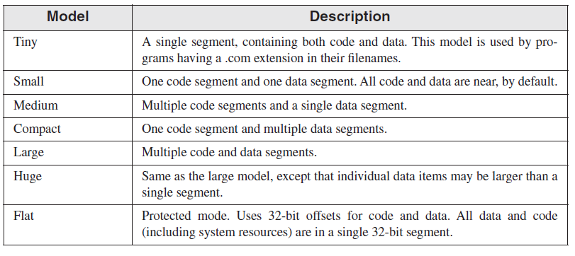

**Memory Options**

Language specifier -> determines calling and naming conventions for procedures and public symbols

Stack distance -> can be NEARSTACK (the default) or FARSTACK

We mostly uses *.model flat, STDCALL*

**STDCALL** is the language specifier used when calling MS-Windows functions.

**Steps to follow**

1. Select **New Project > Visual C++ > Win32 >Win32 Console Application**

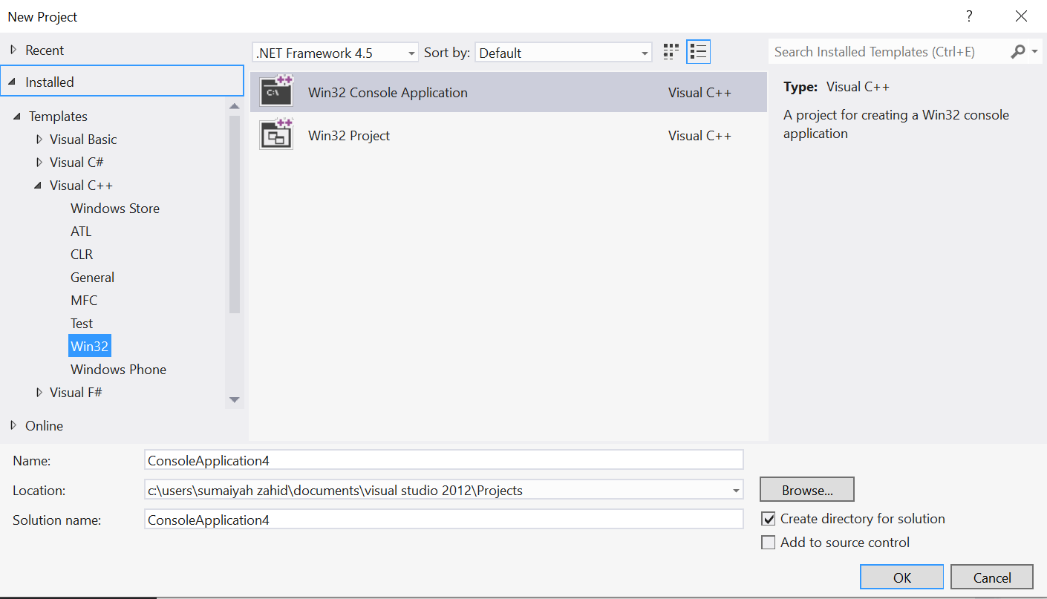

1. Make sure to check Pre Compiled Header

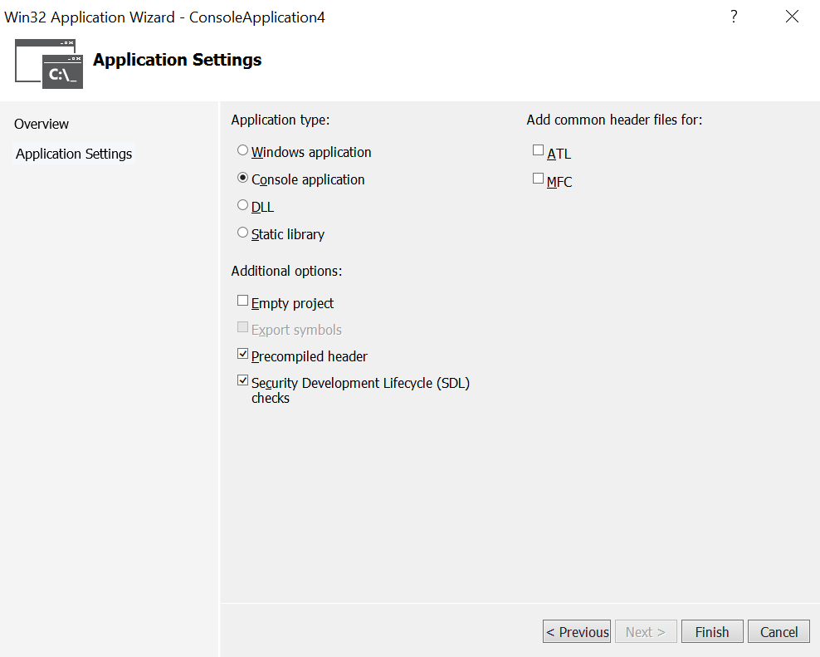

1. Write your C++ code in source file

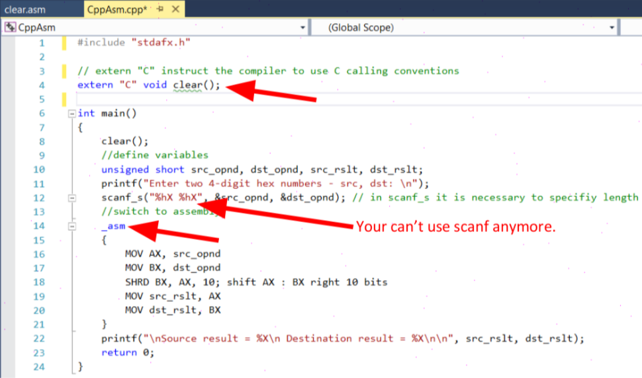

1. Add .asm file to the project

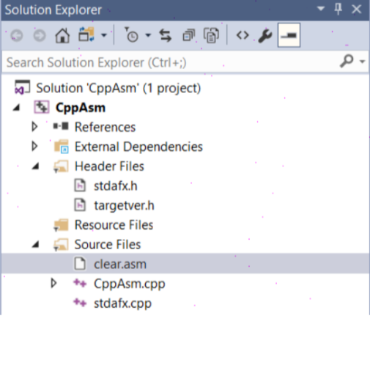

1. Write Assembly code in your .asm file

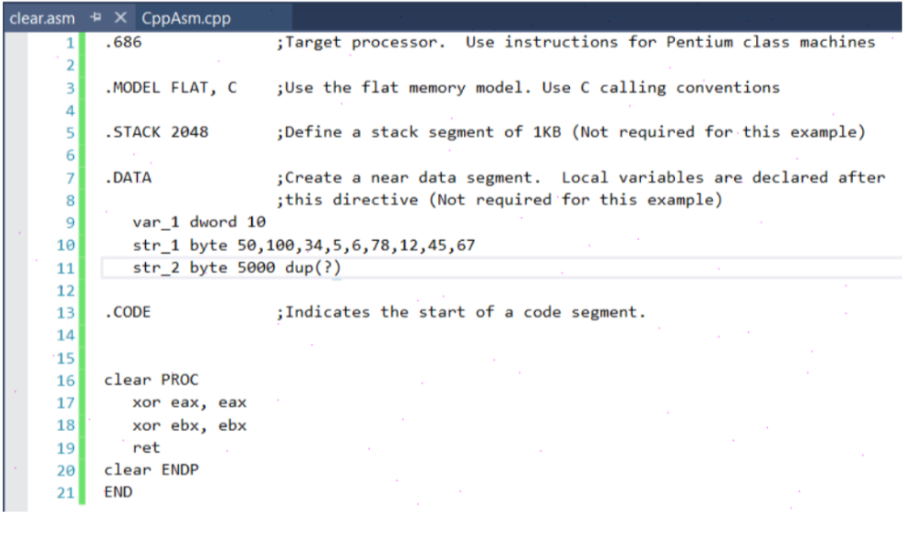

1. Right click on .asm file and select Properties. Select **Configuration Properties > General > Item Type > Custom Build Tool** and Apply the changes.

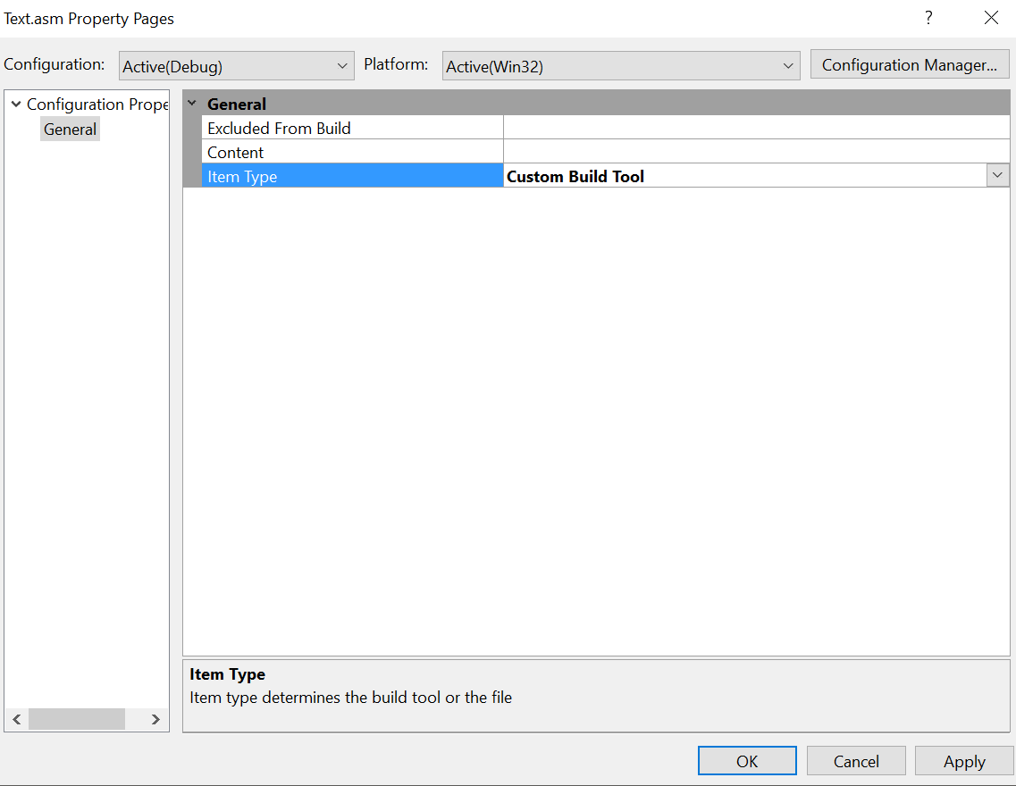

1. Select **Configuration Properties > Custom Build Tool > General**

**Command Line:**

ml -c -Zi "-Fl$(IntDir)%(Filename).lst" "-Fo$(IntDir)%(Filename).obj" "%(FullPath)"

**Outputs:**

$(IntDir)%(Filename).obj

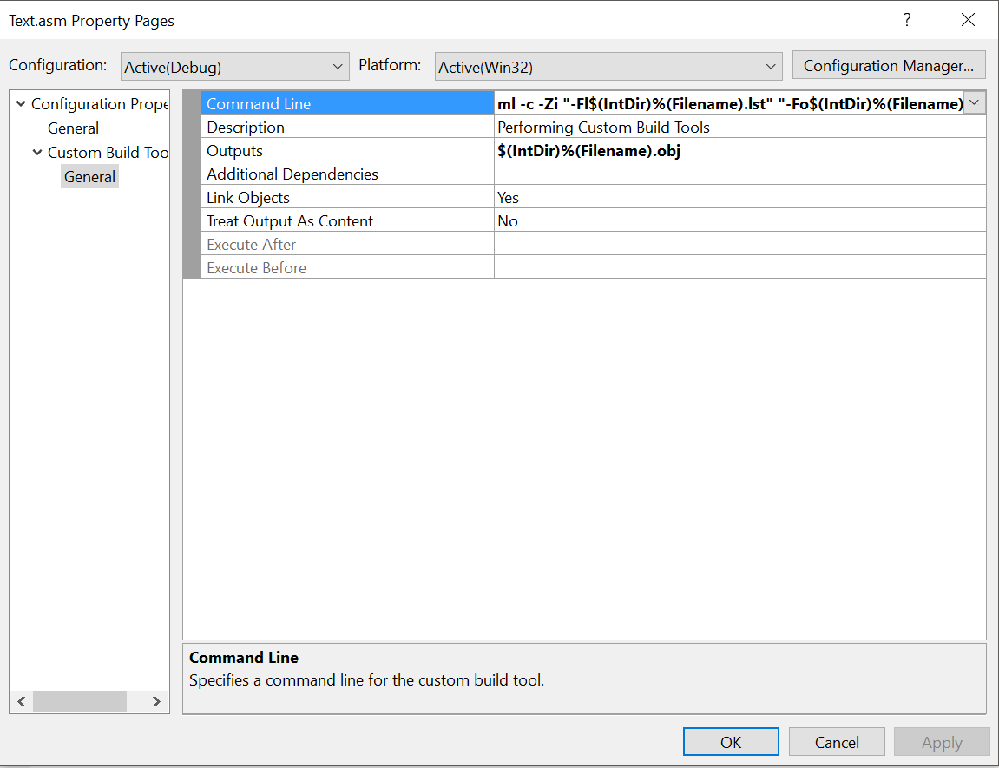

**Example:**

.686 ;Target processor. Use instructions for Pentium class machines

.MODEL FLAT, C ;Use the flat memory model. Use C calling conventions

;INCLUDE Irvine32.inc

.STACK 2048 ;Define a stack segment of 1KB (Not required for this example)

askForInteger PROTO C

showInt PROTO C, value:SDWORD, outWidth:DWORD

OUT_WIDTH = 8

ENDING_POWER = 10

.data

intVal DWORD ?

.CODE ;Indicates the start of a code segment.

clear PROC

xor eax, eax

xor ebx, ebx

INVOKE askForInteger ; call C++ function

mov int Val, eax ; save the integer

mov ecx, ENDING_POWER ; loop counter

L1:

push ecx ; save loop counter

shl intVal,1 ; multiply by 2

INVOKE showInt, intVal,OUT_WIDTH

pop ecx ; restore loop counter

loop L1

ret

clear ENDP

END

**Cpp**

#include "stdafx.h"

#include <iostream>

#include <iomanip>

using namespace std;

// extern "C" instruct the compiler to use C calling conventions

extern"C" {

void clear();

int askForInteger();

void showInt(int value, int width);

}

int main()

{

clear( );

return 0;

}

int askForInteger()

{

int n;

cout << "Enter an integer between 1 and 90,000:";

cin >> n;

return n;

}

// Display a signed integer with a specified width.

void showInt( int value, int width )

{

cout << width

cout << value;

}

**ACTIVITIES:**

1. Take two number as input and perform AND operation using _asm directive.
2. Take two number as input and perform OR operation using _asm directive
3. Generate first 10 number of Fibonacci series through asm directive calling in C/C++.
4. Write a program finds smallest of the three integers
5. Write a program finds largest of the two integers
6. Write a program to sort an array of 10 integers using c to Assembly call and vice versa.
7. Write a program to find factorial of a given number.